A LEVEL PHYSICAL EDUCATION (Linear)

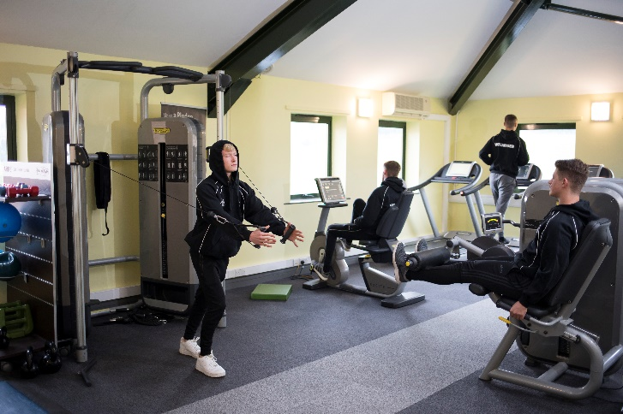
WHAT IS PE?

Physical Education involves focusing on the theoretical aspects of participation and performance in physical activity as part of a balanced, active and healthy lifestyle.

The course focuses on:
- Increasing your theoretical and physical competence
- Developing your involvement and effectiveness in physical activity
- Enabling you to become informed and discerning decision makers in relation to your and others’ involvement in physical activity

Please note that this is a very different course to GCSE PE as there is a strong theoretical element, much of it scientific and there is much less focus on practical activities.

WHY SHOULD I STUDY PE?

If you are:
- A keen sports person, who is enthusiastic about developing your theoretical knowledge and gaining a greater understanding of the scientific and socio-cultural aspects of performance
- If you wish to pursue a career within any of the sports fields

USEFUL SKILLS & INTERESTS

It is essential that you have a keen interest in both theoretical and practical aspects of sport. You are expected to be playing at least one sport on a regular basis to school / club level. Any leadership / coaching awards will be of benefit when it comes to the practical and appreciation of performance assessments.

COURSE STRUCTURE & CONTENT

The A Level course consists of four mandatory components, consisting of the following areas of study:

Component 01: Physiological factors affecting performance
- Applied Anatomy and Physiology
- Exercise Physiology
- Biomechanics

Component 02: Psychological factors affecting performance
- Skill Acquisition
- Sport Psychology

Component 03: Socio-cultural Issues in Physical Activity and Sport
- Sport and Society
- Contemporary Issues in Physical Activity and Sport

Component 04: Performance in Physical Education (NEA – Non Examined Assessment)
- Performance or Coaching of an activity taken from the approved lists
- Evaluation and Analysis of Performance for Improvement (EAPI)

HOW WILL I BE ASSESSED?

Component 01: Physiological factors affecting performance
- 2 hour written exam paper out of 90 marks which is worth 30% of the total A Level.

Component 02: Psychological factors affecting performance
- 1 hour written exam paper out of 60 marks which is worth 20% of the total A Level.

Component 03: Socio-cultural Issues in Physical Activity and Sport
- 1 hour written exam paper out of 60 marks which is worth 20% of the total A Level.

Component 04: Performance in Physical Education (NEA – Non Examined Assessment)

You will be internally assessed through the NEA in one practical activity (either performing or coaching one chosen activity from the approved lists) which is assessed out of 30. You complete logs of competitive participation in their activities/sports to show their frequency and level of participation. You will be assessed in your performance based on their ability to select and perform appropriate skills consistently, precisely and with control and fluency, adapting them to suit a variety of situations in authentic conditioned, competitive environments for their chosen activity. Below is the list of approved activities:

Activity | Restrictions and allowances | Activity | Restrictions and allowances
Association Football | Cannot be five-a-side or Futsal | Kayaking
Amateur Boxing |  | Lacrosse
Athletics |  | Netball
Badminton |  | Polybat
Basketball |  | Powerchair football
Blind Cricket |  | Rock Climbing
Boccia |  | Rowing
Camogie |  | Rugby  League | Cannot be tag rugby
Canoeing |  | Rugby Union | Can be assessed as sevens or fifteen a side. Cannot be tag rugby
Cricket |  | Sculling
Cycling | Track or road cycling only | Skiing | Must take place on snow, can be indoor or  outdoor
Dance |  | Snowboarding | Must take place on snow, can be indoor or  outdoor
Diving | Platform diving | Squash
Equestrian |  | Swimming
Gaelic football |  | Table Cricket
Goal Ball |  | Table Tennis
Golf |  | Tennis
Gymnastics |  | Trampolining
Handball |  | Volleyball
Hockey | Field Hockey only – no ice or roller hockey | Wheelchair basketball
Hurling |  | Wheelchair rugby

In addition to a practical performance, you will be assessed in the Evaluation and Analysis of Performance for Improvement (EAPI). You will observe a live or recorded performance by a peer in either their own assessed performance activity or another activity from the approved list and provide an oral response analysing and critically evaluating their performance focusing on specific areas.

You will then identify and justify the major area of weakness within the performance to prioritise for improvement and will propose a two – three months development plan to improve the area of performance identified. The development plan will include:

- aims, objectives and timescale for the development plan
- why it is appropriate to spend this length of time on improving this one area
- frequency, duration and focus of sessions
- detailed progressive practices
- detailed coaching points
- potential adaptations to the development plan depending on progress
- how improvement could be measured

COURSE COMMITMENT

This is a very diverse, challenging and demanding course and as such we expect 100% commitment from our students. We set our department standards high and have high expectations and hopes for all our students. High levels of attendance; punctuality; homework submission and independent study are essential if students are to maximise their potential.

COURSE COSTS

At the start of the course you will be given the opportunity to purchase Prior Pursglove College sports kit to wear during lessons and when you are volunteering in the local community. This kit is heavily subsidised by the college. Free gym membership is offered to all students.

ENTRANCE REQUIREMENTS

For entrance on to this course you will need to meet the college standard entry requirements of 5 GCSE passes grades 4 - 9, including a GCSE grade 4 or above in English Language, Science and preferably Maths. You would normally be expected to have successfully completed a GCSE in Physical Education to at least a grade 4 or a pass but we would not exclude you if you had not done so. If PE studied in school, you must achieve a grade 4 or a pass grade.

PROGRESSION ROUTES

These are wide and varied and include:
- University Degree courses (variety of courses – see staff for further discussion)
- Armed Forces
- Teaching
- Police
- Coaching / Leisure development work
- Physiotherapy / Sports Therapy

Some of the students who studied this course at Prior Pursglove College progressed on to:
- Liverpool John Moore University – Sport Business Management
- Northumbria University – Human Nutrition / Law
- Sheffield Hallam University – Physical Activity, Health & Exercise Science
- Sheffield University – Medicine / PE and School Sport
- Teesside University – Sport & Exercise

STUDENT COMMENTS

What our PE students say:

"I chose to study A Level PE at Prior as it's a career I'm considering to pursue in the future and thought Prior would be the best place to help me with this. The PE staff couldn't be friendlier, and go out of their way to help, support and guide you through your time at college."

FURTHER INFORMATION

Full course specifications can be found at www.ocr.org.uk

If you require further information, please contact the subject leader Wendy Stubbs.

Please note that the information in this leaflet is correct at the time of publication, but circumstances may arise which cause us to revise our provision.
June 2020

