A LEVEL ENGLISH LITERATURE

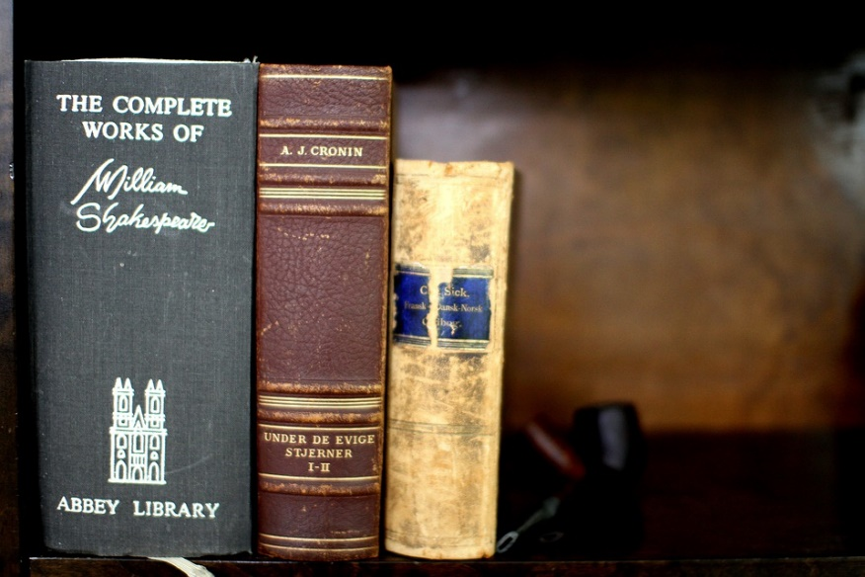
WHAT IS ENGLISH LITERATURE?

English Literature is the study of poetry, prose and drama texts written by writers from the past and present. English Literature is classified as a facilitating subject by the Russell Group Universities.

WHY SHOULD I STUDY ENGLISH LITERATURE?

If you enjoy reading you will find English Literature a stimulating subject. It will put you in touch with minds from very different times and places and it involves studying the writing and ideas of some of the most creative and original
users of the language.

USEFUL SKILLS & INTERESTS

You must be a keen reader and you must enjoy the challenge of developing your understanding of more complex texts. The subject combines well with an interest in creative writing and the study of English Language, History or Media Studies.

COURSE STRUCTURE & CONTENT

This course aims to build on what learners know already from GCSE, introducing learners to the discipline of advanced literary studies and requires reading of all the major literary genres of poetry, prose and drama.

The emphasis in class will be on discussion and active exploration of the texts, continually developing your study skills to become an effective, independent learner. You will also be encouraged to engage in wider reading outside of the classroom thus extending your experience and appreciation of literature.

Over the course of two years you will study a minimum of eight texts.

Paper one - Aspects of Tragedy

- Othello by William Shakespeare
- A selection of poetry by John Keats (Lamia, Isabella, La Belle Dame Sans Merci, Eve of St Agnes)
- Death of a Salesman by Arthur Miller

Paper 2 - Elements of Crime Writing

- The Murder of Roger Ackroyd by Agatha Christie
- When Will There Be Good News? by Kate Atkinson
- Poetry Anthology by George Crabbe, Robert Browning and Oscar Wilde (Peter Grimes, The Laboratory, My Last Duchess, Porphyria’s Lover, The Ballad of Reading Gaol)
Non examined Assessment - Theory and Independence

- One poetry and one prose text, applying a different section of Critical Anthology to each
You will be also expected to read up to three texts independently for coursework.

HOW WILL I BE ASSESSED?

You will be assessed over the two years by your teacher through essay responses, presentations and independent research tasks, developing your skills and understanding in preparation for the summative assessment at the end of year two.

This will include two exams – one open book, one closed book - as well as an independent coursework portfolio which consists of two essays.

COURSE COMMITMENT

You will be expected to read around the subject and study intensively in your own time. You can expect around four hours of homework per week. Throughout the course we will urge you to read texts, which are not on the specification. We give you reading lists and encourage you to keep a Reading Diary, as well as joining our book club enrichment activity.

COURSE COSTS

The course costs are mainly for set texts, which should be no more than £25 per year. Often books can be bought from students in the year above you. There will be one-off costs for trips, e.g. to the theatre, if you wish to attend them.

ENTRANCE REQUIREMENTS

The college requires 5 GCSE passes grades 4 - 9 for entrance onto this course including English Language and English Literature. The jump from GCSE to A Level work can be quite hard, but as long as you bring to the course an enthusiasm for study and are prepared to attend workshops as required by your teacher, you should do well.

PROGRESSION ROUTES

An A Level in English Literature is looked on favourably by universities and can lead to a range of university degrees – English Literature, Law and even Medicine, where it can be used to show skill in communication.

Some of the students who studied this course at Prior Pursglove College progressed on to:
- Birmingham University – American & Canadian Studies and English Literature with Year Abroad
- Greenwich University – Law
- Leeds University – English, Language & Education
- Liverpool John Moore University – Drama & English / Early Childhood Education / Law
- Loughborough University – English & Drama
- Manchester University– English/History / Primary Education
- Northumbria University – English Literature & Creative Writing / Journalism & English Literature / English Literature
- Sheffield Hallam University – Primary Education with QTS
- Sheffield University – English Literature
- Sunderland University – Drama
- Teesside University – English Studies / Multimedia Journalism
- York St John University – American Studies & Film Studies / Primary Education

STUDENT COMMENTS

What our English Literature students say:

“When I came to college I chose English Literature because I loved reading. Every book we’ve studied has had individual reasons for being engaging and so it’s been difficult to be bored. The teachers are very supportive and my knowledge has vastly improved across a range of genres and writing styles. English Lit is now my favourite subject.”

“I am really enjoying my English Literature course. You can clearly see that the teachers are enthusiastic about the subject and this is reflected in the students, which leads to interesting and insightful class discussions.”

“Studying English Literature has greatly developed my analytical skills and I feel like I have the skills to help me achieve my goal of studying English at University.”

“Studying this subject is a good way to be creative and explore and develop a love of literature. A Level English Literature gives you the opportunity to study a variety of texts and interpret them in your own way.” –
“English Literature has helped me in all aspects of college and my job. I will be taking a lot from it and I have thoroughly enjoyed it in both years of the course!”

“English Literature is my favourite subject as the course is diverse and every aspect allows for creativity and although sometimes challenging, it’s extremely rewarding. The staff are very helpful and caring and I strongly recommend anyone considering taking English to do so.”

“English Literature is a really interesting and challenging subject – it’s hard work, but a lot of fun too.”

FURTHER INFORMATION

If you require further information please contact the following subject teachers:
j.ingram@pursglove.ac.uk k.robson@pursglove.ac.uk. d.bichener@pursglove.ac.uk

Please note that the information in this leaflet is correct at the time of publication, but circumstances may arise which cause us to revise our provision.
April 2021

