A LEVEL GEOGRAPHY
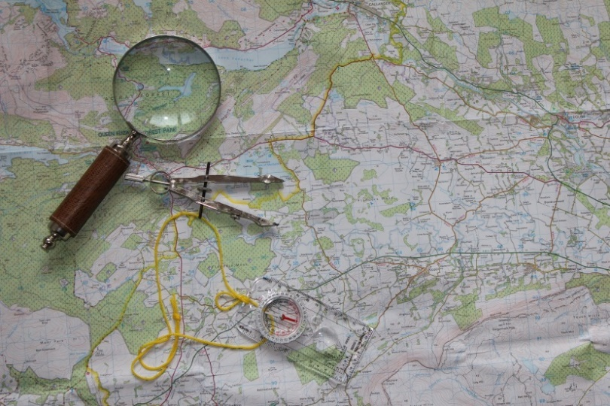
Many of our students study both Geology and Geography. This serves to ease the burden of the workload and support other science and humanities studies. Both subjects are:

- Taught in designated classrooms and well equipped teaching laboratory

- Taught from scratch - no prior knowledge is assumed and includes fieldwork locally and internationally (optional)

- Geography A Level has had 100% pass rate for over 5 years. (2014 - 5 students getting A*)

WHAT IS GEOGRAPHY?

Geography examines the interaction of people and their environments throughout the subject content. The use of regional examples and case studies is seen as fundamental to a meaningful understanding of geographical concepts and principles. For example: Why is there such a variation in life expectancy across the UK? Why is obesity increasing in the N. East? Why are there more babies being born in London? How have tourists increased desertification in Southern Spain?

WHY SHOULD I STUDY GEOGRAPHY?

Do you have an enquiring mind that likes to study geographical and scientific evidence and link these to current affairs and people? You will not be disadvantaged by not having a GCSE in Geography. The second year modules provide an opportunity to deepen and broaden your understanding - topics include weather, volcanoes, earthquakes and world cities. Geography is a National Curriculum subject, ideal for potential teachers and combines well with almost any other A Level.

Geographers at Prior travel further! We have offered trips to London, Manchester or New York in the second year of the course depending on demand and finances. This is a chance to experience life and see many famous sights and in a World City.

COURSE STRUCTURE & CONTENT

Physical geography  40% 2.5 hrs exam | Human geography  40% 2.5 hrs exam | Geography investigation and skills  20% Coursework 4000 words
- 1. Water and carbon cycles  - 2. Hot desert environments and their margins.  - 3. Hazards | - 7. Global systems and global governance  - 8. Changing places  - 9. Contemporary urban environments | Students complete an individual investigation which must include data collected in the field. The individual investigation must be based on a question or issue defined and developed by the student relating to any part of the specification content.

HOW WILL I BE ASSESSED?

This qualification is linear which means that students will sit all their exams and assessment at the end of the course and is it expected that they will consist of multiple-choice, short answer, levels of response, extended prose.

COURSE COMMITMENT

You should aim for 100% lesson attendance and homework completion to deadlines set. All students are required to undertake fieldwork in relation to processes in both physical and human geography. Students must undertake four days of fieldwork during their A-level course. Fieldwork can be completed in a number of ways: locally or further afield, on full days or on part days. Schools and colleges will be required to confirm that all A-level Geography students have been given an opportunity to fulfil this requirement.
(under Ofqual's course guidelines).

COURSE COSTS

Local field visits usually cost around £2-10 each, as a contribution towards transport costs. The optional residential visits are considerably more expensive and depend on timing, location and numbers travelling.

ENTRANCE REQUIREMENTS

For entry on to this course you will need to meet the college standard entry requirements for Advanced Level study of 5 GCSE passes (grades 4 - 9) including a minimum of a grade 5 in Maths, English Language and Science. If you have studied geography at GCSE it must be at least a grade 4. You will not be disadvantaged by not having a GCSE in Geography. If in doubt, please discuss with us.

PROGRESSION ROUTES

Many of our students choose Geography or Earth Science degrees at University. There are many careers that use Geography, in particular; Law, Accountancy, Armed Services, Planning, Teaching, Journalism and even Medicine to name but a few! Some of the students who studied this course at Prior Pursglove College progressed on to:

- Loughborough University – Geography / Sports Science  - Northumbria University – Environmental Management / Geography  - Sheffield University – Civil Engineering  - University College London – Medicine  - York St John University – Primary Education | - Bradford University – Biomedical Science  - Hull University – Geography & History / Geology with Physical Geography  - Keele University – Geography / Maths  - Leeds University– Geological Sciences  - Leicester University – Geology  - Liverpool John Moore University – International Relations & Peace Studies

STUDENT COMMENTS

What our Geography students say:

“If you like to know about the world and the history of the world, e.g. formation, fossils, then this is the course for you. It’s interesting and enjoyable. The trips are enjoyable, especially to New York – that was a great experience.

“Geography is very interesting and fun.”

FURTHER INFORMATION

For further information, please contact the subject leader, Steven Bury.

Please note that the information in this leaflet is correct at the time of publication, but circumstances may arise which cause us to revise our provision.
March 2021

