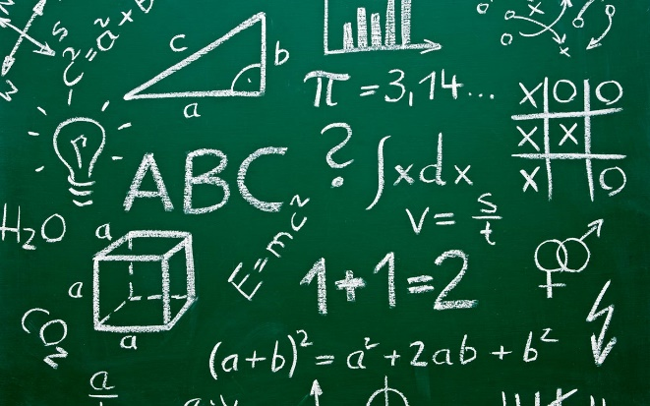
A LEVEL MATHEMATICS AND
FURTHER MATHEMATICS

WHAT IS MATHEMATICS?

This course builds on GCSE level Mathematics emphasising how mathematical ideas are interconnected and can be applied to help make sense of data, to understand the physical world, and to solve problems in a variety of contexts. It prepares students for further study and employment in a wide range of disciplines involving the use of mathematics.

There are four broad areas (depending on the course chosen):

- Pure Maths – is the foundation of all Maths courses and includes topics such as algebra, trigonometry and calculus.
- Mechanics – is the mathematics of force and motion as applied to objects or systems and includes topics such as constant acceleration, Newton’s laws, projectiles and momentum.
- Statistics – involves the extension of ideas of data handling and probability, with a view to being able to draw conclusions or answer questions like ‘Does drug X reduce heart attacks?’
- Decision – involves the use of algorithms to solve practical problems like ‘the travelling salesperson problem’ (how to visit several towns and return home by the shortest route); this has applications to decision making in industry, business and computing.

WHY SHOULD I STUDY MATHEMATICS?

Mathematics is a useful if not essential tool in many areas of study, particularly science and can be stimulating and challenging in its own right.

Mathematics A Levels are highly regarded by employers, universities and colleges for a wide range of courses and careers.

USEFUL SKILLS & INTERESTS

For Mathematics/Further Mathematics you should be comfortable when handling algebra as it is a vital part of the courses.

COURSE STRUCTURE & CONTENT

There are two different courses to choose from

Mathematics: Students will be assessed on their knowledge of

- Pure Mathematics (2/3): Proof, Algebra and functions, Coordinate geometry in the (x,y) plane, Sequences and series, Trigonometry, Exponentials and logarithms, Differentiation, Integration, Numerical methods and Vectors.

- Statistics (1/6): Statistical sampling, Data presentation and interpretation, Probability, Statistical distributions and Statistical hypothesis testing.

- Mechanics (1/6): Quantities and units, Kinematics, Forces, Newton’s laws and Moments.

The assessment objectives include a greater emphasis on modelling, problem-solving and reasoning, so some questions are likely to be longer with less scaffolding, building on the increase in problem-solving in GCSE Mathematics.

Further Mathematics: Studied alongside mathematics, students will be assessed on their knowledge of:

- Pure Mathematics (1/2): Proof, Complex numbers, Matrices, Further algebra and functions, Further calculus, Further vectors, Polar coordinates, Hyperbolic functions and Differential equations.

- Pure/Statistics/Mechanics/Decision (1/4 + 1/4): Students will study two units taken from these.

HOW WILL I BE ASSESSED?

These linear courses and will be examined at the end of the course by written examinations
- Mathematics – three 2 hour papers (2 pure maths, 1 mechanics/statistics)
- Further Mathematics – four 1.5 hour papers (2 pure maths, 2 pure/mechanics/statistics/decision)

CHOOSING THE RIGHT COURSE

- In choosing your course you may well consider your GCSE grade, other subjects being studied, possible career intentions as well as personal preference.
- Students taking Science subjects will often want to study Mathematics
- Students choosing subjects with a statistical content like Psychology or Business Studies would benefit from studying Mathematics.
- Further Mathematics goes well with almost anything and gives an excellent basis for many Mathematics, Science or Engineering degree courses.

COURSE COMMITMENT

Mathematics uses one block on the timetable and Further Mathematics takes up two blocks. By the nature of the subject we are always building on previous work so it is vital to keep up to date and learn the work thoroughly which is covered by completing regular assignments and practice questions.

COURSE COSTS

For all the courses a casio fx-991EX scientific calculator is required (which will be available to purchase from the College resource centre). Graphical calculators can be used by students but are not essential.

ENTRANCE REQUIREMENTS

For entrance on to this course you will need to meet the college standard entry requirements for advanced study of 5 GCSE passes (grades 4 - 9), including GCSE grade 6 or above in Mathematics and for Further Mathematics students will need at least a GCSE Maths grade 8 or 9.

PROGRESSION ROUTES

All the above A Levels can enable progression to an extremely wide range of degree courses, depending on subject combinations. Mathematics is essential for many science based courses and Further Mathematics is recommended for many Mathematics / Physics / Engineering degrees.

FURTHER INFORMATION

Full course specifications can be found at http://qualifications.pearson.com/en/subjects/mathematics.html
Should you require further information please contact the Maths team.

Please note that the information in this leaflet is correct at the time of publication, but circumstances may arise which cause us to revise our provision.
March 2021

